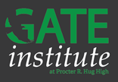

***Don’t Miss Out!***

**Applications are available online from November 15th – January 1st!**

**https://www.washoeschools.net/Page/13962**

**The GATE Institute, *a collaboration between the GATE program, Hug High School, and AP Capstone,* offers gifted and talented students a unique experience to fit the whole student.**

* **AP Capstone Diploma**
* **GT Specific Classes & Responsible Scheduling**
* **Advanced Academic Pathways**
* **GT Endorsed Teachers**
* **Dual-Enrollment in the Health Science Academy**
* **One to One Technology**

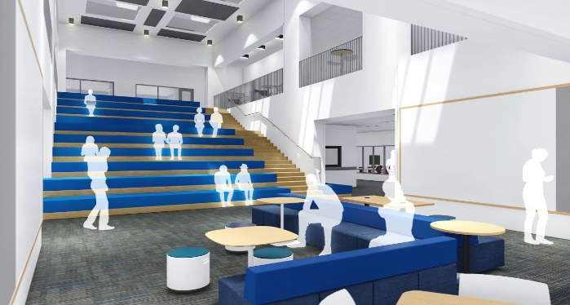**What is AP Capstone?**  
The College Board’s AP Capstone is an innovative and engaging ***college-level program for high school students*** that complements and enhances discipline-specific AP courses. It’s built on two courses—***AP Seminar*** and ***AP Research.*** AP Capstone is the pinnacle of the high school experience, encouraging a passion for learning and transforming students into curious, collaborative, and independent thinkers with skills that are valued and sought after by colleges and universities.

**The GATE Institute is moving to the NEW HIGH SCHOOL!**

**Upon completion of the new high school at Wildcreek, students enrolled in the GATE Institute will be enrolled at the new school.**

**For more information, please see:** **<https://www.youtube.com/watch?v=hl7L6O5lFi8&feature=youtu.be>**

**The Department of Gifted and Talented Education Program Office: 775-789-3420** [giftedandtalented@washoeschools.net](mailto:giftedandtalented@washoeschools.net)